**Week 3: Asynchronous Design Studio**

3D printed community projectPART 1: Community Choice and Survey ([Statistics Canada 2018](https://www150.statcan.gc.ca/n1/pub/75f0002m/75f0002m2019011-eng.htm#a8))

**Overview**

This activity aligns team members’ perspectives and establishes the first set of design decisions for the project. Particularly, the team will brainstorm on the following key question that will influence future design decisions in the project: Given a choice of three very different Canadian communities, which ones will you choose for the design? Also, the activity provides a “macro-level” sense of the human dimension in housing and explores public opinions on key housing issues, according to the surveys and research conducted regularly by various levels of government.

# **Step 1: Choice of community (10 minutes)**

Consider the following 3 communities in Canada:

**Iqaluit, Nunavut**, is the capital of the Territory of Nunavut in the Canadian north. Due to its distance from major population and urban centres, materials, labour, equipment and pretty much everything is much more expensive to procure. The typical northern climate and landscape will also provide significant challenges to home design. As well, its blend of indigenous people and those from the rest of Canada present some important considerations.

* Elevation: 30 m
* Area: 52.5 km²
* Population: 7,740 (2016)
* Climate profile ([from climate-data.org](https://en.climate-data.org/north-america/canada/british-columbia/langford-11994/#climate-graph))

Iqaluit, Nunavut heavy precipitation and high temperature occurs around August


**Langford, British Columbia**, is a community on the southern coast of Vancouver Island. In 2021, a survey chose this city as the “most livable place” in Canada ([Mycowichanvalleynow.com article](https://www.mycowichanvalleynow.com/64182/vancouver-island-communities-most-livable-places-in-canada/)). It is a sought after community especially since the start of the Pandemic that triggered significant movement of families from dense urban areas to smaller, quieter locations. This region of the country is noted for its natural beauty and general sensitivity to environmental and climate issues. It is also notable for some of the highest housing prices in Canada.

* Elevation: 76 m
* Area: 39.94 km²
* Population: 35,342 (2016)
* Climate profile ([from climate-data.org](https://en.climate-data.org/north-america/canada/british-columbia/langford-11994/#climate-graph))

Langford, British Columbia heavy precipitation occurs in Winter, high temperature occurs in Summer


**Hamilton, Ontario** is the home of McMaster University and the 9th most populous city in Canada. Like most large Canadian communities, its population has a modern mix of people from many parts of the world. Historically, Hamilton was a major industrial centre and port with a major concentration of steel companies. More recently its economy has been marked by the sometimes difficult transition from this industrial past to a more modern economic framework. Today, the city is considered a centre of progressive attitudes and initiatives that balance the need for economic development with environmental protection and livability.

* Area: 1,138 km²
* Weather: 3 °C, Wind W at 11 km/h, 87% Humidity
* Population: 579,200 (2017)
* Climate profile ([from climate-data.org](https://en.climate-data.org/north-america/canada/ontario/hamilton-60/#climate-graph))

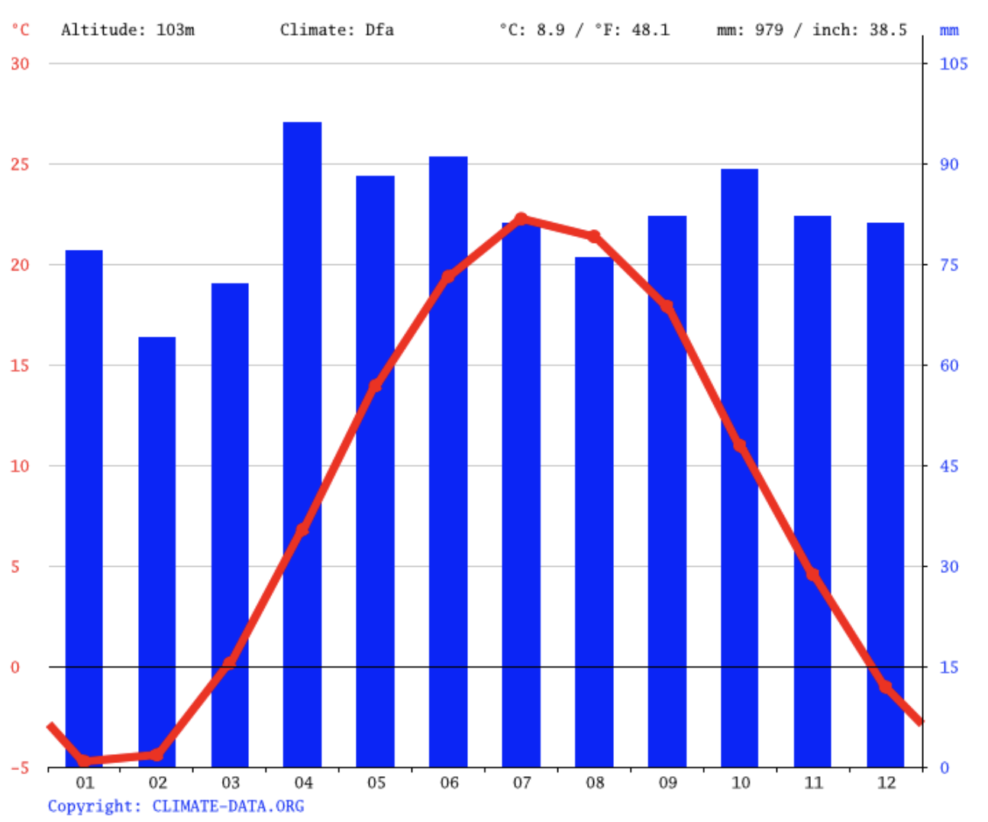

**Question 1: Recommendation**

Which community did you choose and what are the key reasons (maximum 3 reasons)

I chose Hamilton. This is because the design of 3D printed housing in Hamilton will tackle 2 problems that are affecting all of Canada. Firstly, 3D printed housing will help to solve the homelessness crisis in Hamilton by making housing more common and affordable. In addition, 3D printed housing will also contribute to solving the financial house crisis plaguing the GTA by creating more housing options and reducing prices overall.

# **Step 2: Community Survey (20 minutes)**

Housing is one of the most important factors in our lives. Day to day, it helps frame our comfort, safety, and productivity and it is also a major factor influencing our decisions on careers, families, and other very personal elements. Accordingly various levels of government regularly conduct surveys and research to assess public opinions on key housing issues. In 2018, Statistics Canada, of the Government of Canada, conducted a *Canadian Housing Survey*. In particular, they wanted to get a sense of Canadian perspectives on,

* Having enough space overall in your home
* Having enough bedrooms
* Being affordable
* Its condition (e.g. well maintained)
* Blocking regular noise from outside or from neighbours
* Being safe and secure within the home
* Being energy efficient
* Being able to maintain a comfortable temperature in the winter
* Being able to maintain a comfortable temperature in the summer

Your design team has been asked to initially consider the data arising from this survey to inform some of your initial thinking and analysis. Among the many charts and data sets presented in the [final report](https://www150.statcan.gc.ca/n1/pub/75f0002m/75f0002m2019011-eng.htm#a8), are the five charts included in this section.

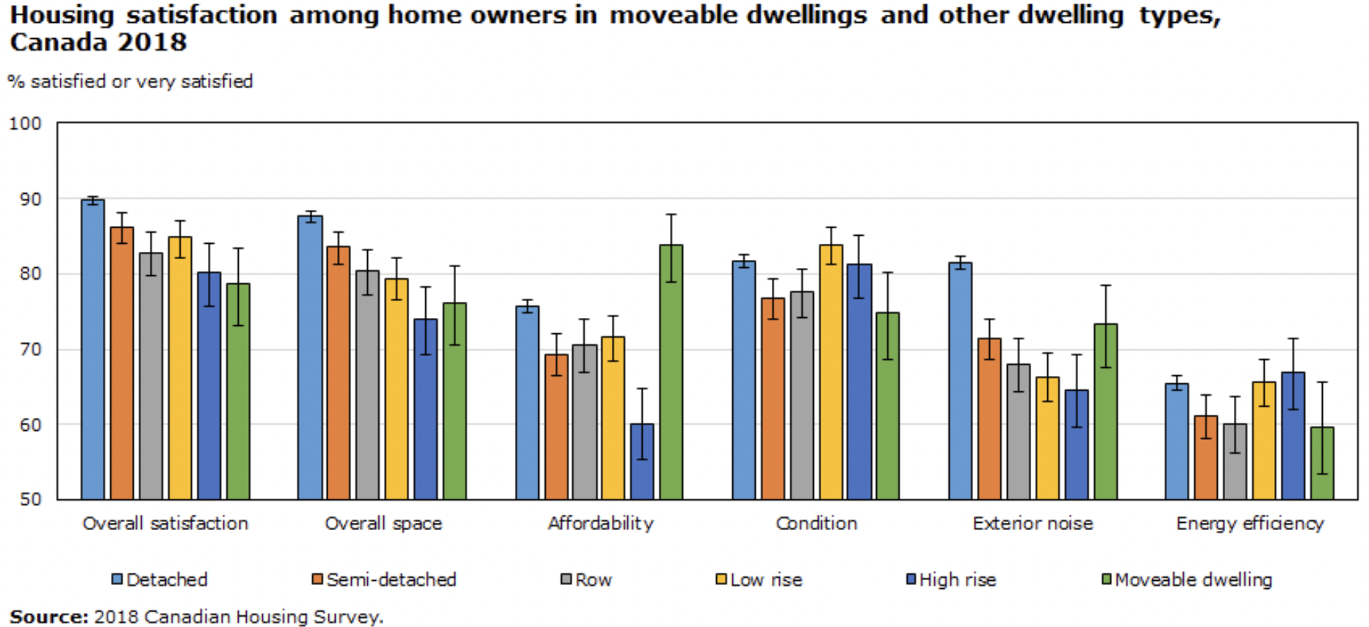

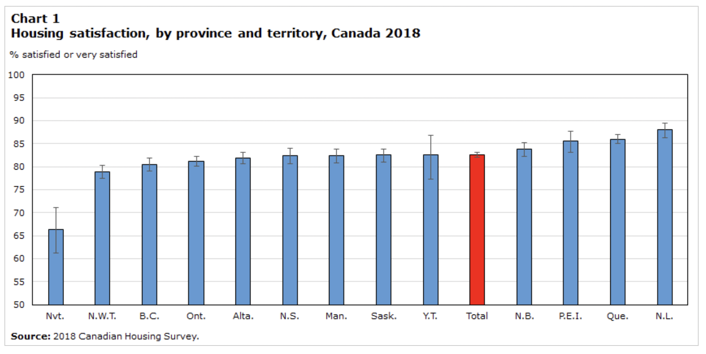

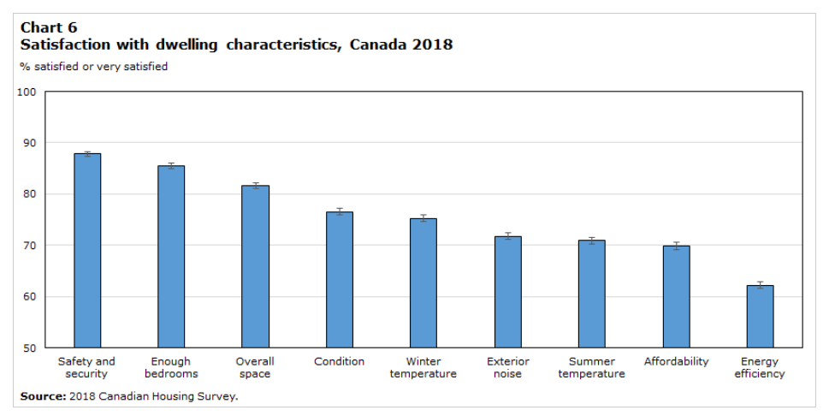

**Question 1:** Clearly there is not enough data here to exactly answer detailed questions, but could they indicate a possible trend? But for now, you are asked to do your best with imperfect data. Accordingly, you are asked to give your first thoughts on which of three community layouts you would recommend among the following three options:

1. 30 detached single family dwellings: assume all are to be owned by residents.
2. 15 detached + 30 rowhouses: assume all are to be owned by residents
3. 10 detached + 20 rowhouses + 2 low-rises of 30 dwellings each: assume detached and rowhouses are owned and dwellings in low-rises are rented.

Feel free to explore that report and its source data via the link: [Canadian's satisfaction with their housing](https://www150.statcan.gc.ca/n1/pub/75f0002m/75f0002m2019011-eng.htm#a8) .

I would recommend 30 detached single family dwellings. This is because according to the charts above, residents are most satisfied overall with this style of housing. Observing the first graph, detached homes are top 2 in satisfaction of space, affordability, condition, exterior noise, and energy efficiency. Because of this, I feel that detached homes would be most appealing to the buyer. Also, owners of detached and multi-unit houses are most satisfied overall in densely populated areas (such as Hamilton) as per the third graph.

**Question 2:** If you were to plan a new survey of the residents of the community that your group has chosen, what are 3 important questions that you would want to ask in order fill the gaps that that Statistics Canada survey leaves?

First, I would ask what their salary range is. This question is rather intrusive, but it is important to consider a homeowner’s income when asking about satisfaction with the price of their large and detached home. One who’s income allows them to easily purchase a detached home tends to be satisfied with the price, while one who cannot afford such a house is most likely less satisfied with the high prices. Second, I would ask how many people reside in the house. Residents housing families (4-7 people) could be dissatisfied with the space in their home if they lived in a smaller home (row/high rise/low rise), while those living alone, with a spouse, or with a roommate could report higher satisfaction in smaller housing. Third, I would ask about location and transportation options available in the house’s area. I think that the surrounding environment is a big contributor to one’s satisfaction with their house’s condition and affordability, and that transportation infrastructure is an important consideration when evaluating satisfaction.

PART 2: Stakeholder input

**Overview**

The purpose of this activity is to obtain a better sense of key human dimensions at the regional level in this project. In this activity, you are reflecting on a hypothetical subsequent survey within the target community following the initial assessment that the team did on the high-level survey from Statistics Canada.

# **Step 3: Stakeholder (40 minutes)**

First, watch the 3DH Stakeholder video and then reflect on the questions posed in this activity brief.

Paraphrasing the Stakeholder Input

* Stakeholder 1: “I think this technology is amazing! It will solve so many housing problems.”
* Stakeholder 2: “Are you sure they are environmentally friendly? That looks like an awful lot of concrete.”
* Stakeholder 3: “What are you crazy? You trying to put me out of a job?”
* Stakeholder 4: “Seems like a cool idea but the houses are really ugly. And is it actually cheaper at the end of the day?”
* Stakeholder 5: “We gotta try something right? Housing situation is getting really bad for a lot of folks here.”

**Question 1:** Reflecting on the stakeholder comments, what do you think some of the most difficult decisions will be? i.e. what are the conflicting comments? List at most 3.

One of the most difficult decisions is the automation factor of the 3D printed housing construction. In cases where the house is directly printed onto the property, there is much less need for those in the construction industry (like stakeholder 3) to work on and assemble the houses as if instead parts were printed in a factory and shipped to be assembled by a construction team. However, the direct printing approach would most likely be cheaper (stakeholder 4 and 5) since parts would not need to be shipped and labour would be reduced. So, I expect a difficult decision to be whether to pre-print parts in a factory or to print directly to the site. Another decision I expect to be very difficult would be the printing compound’s material selection. In this case, concrete would probably be the most cost effective (stakeholder 4 and 5), but also probably the least appealing visually (stakeholder 4) as well as not the most environmentally friendly option (stakeholder 2). Choosing a material that compromises these factors is going to be a difficult and long process.

**Question 2:** Based on your interpretation of stakeholder comments, which are the top factors (maximum 3) that should influence any design decision on the PERFORMANCE screening of the design.

*2a: For MATERIAL choice, which factor, concern or comments will be most important for the PERFORMANCE SCREENING consideration in your decision? (maximum 3)*

The material chosen must be robust so to ensure houses can undergo extreme weather unscathed and also have a long life with minimal decay. The material must be easy to work with: it should be easy to render it to a liquid state for printing and it should solidify quickly and into a rigid structure. These two factors will greatly improve the appeal of the homes and greatly reduce the cost of printing.

*2b: For TECHNOLOGY choice, which factor, concern or comments will be most important for the PERFORMANCE SCREENING consideration in your decision? (maximum 3)*

*consideration in your decision? (maximum 3)*

*2c: For NEIGHBOURHOOD LAYOUT choice, which factor, concern or comments will be most important for the PERFORMANCE SCREENING consideration in your decision? (maximum 3)*

*consideration in your decision? (maximum 3)*

# **Step 4:**

Communicate your individual conclusions with your team-mates. Once you have completed your individual consideration and completed this worksheet, please share with all of your teammates as you will all need to have a sense of the others’ thoughts prior to your Synchronous Design studio session. Also, when you receive others, please review their thoughts and try to identify places where you may have a difference of opinion or are in strong agreement. Reflect on these differences or similarities prior to your next group session.

Submission Instructions

1. Upload a *.**PDF** copy of the Wk-3 - Asynchronous Design Studio 3 Worksheet to the Avenue Dropbox titled **Asynchronous Design Studio Week 3** by Friday, Jan 28th, end of day (5:30pm)
   * Use the following naming convention: **macID_AsynchDS3.pdf**